Adding a new Fixture to a Display Group

When a display group needs a Fixture added, the backend SQL server needs to be accessed. Manually access the CRDB SQL Prod server – 172.28.4.147, create a new fixture or link a fixture to a display group.

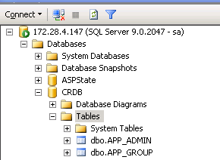 | Access the CRDB SQL Prod Server  Mstsc to 172.28.4.147  sa/IBM@1234  Access SQL database  Go to CRDB/Tables
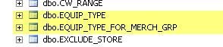 | The following tables need to be modified  dbo.EQUIP_TYPE  dbo.EQUIP_TYPE_FOR_MERCH_GRP
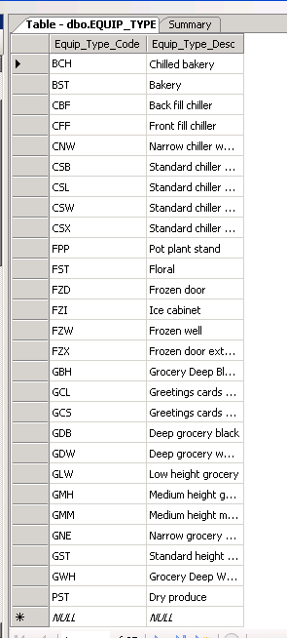 | The dbo.EQUIP_TYPE table will contain the following  EQUIP_TYPE_CODE –  3 character equipment type  And  EQUIP_TYPE_DESC –  description of equipment type  Verify that the EQUIP TYPE CODE is in the table  If it’s not, create one with appropriate EQUIP_TYPE_DESC  Once you’ve verified that the equipment is already in the EQUIP_TYPE table, you will have to link the Display Group with the Equipment Type
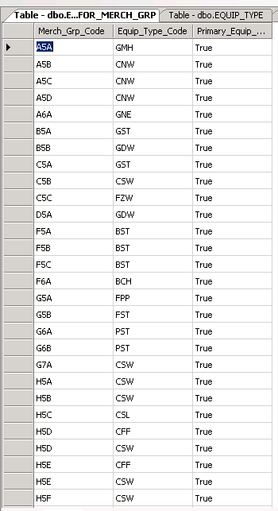 | Access the EQUIP_TYPE_FOR_MERCH_GRP table  Add the 3 character Display Group code in the MERCh_GRP_CODE field, add the EQUIP_TYPE 3 character code in the EQUIP_TYPE_CODE field, enter “true” in the Primary_Equipment_Ind field.  Once all is entered The Display Group is now linked to the new Fixture equipment.

Error appears when you’re trying to enter a DG that does not exist in dbo.MERCH_GRP
The DG should have an entry in dbo.MERCH_GRP, the only way to enter data in dbo.MERCH_GRP is by Uploading DG via excel.

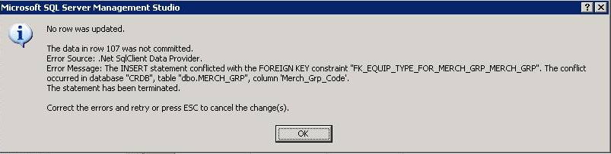

The dbo.MERCH_GRP table

